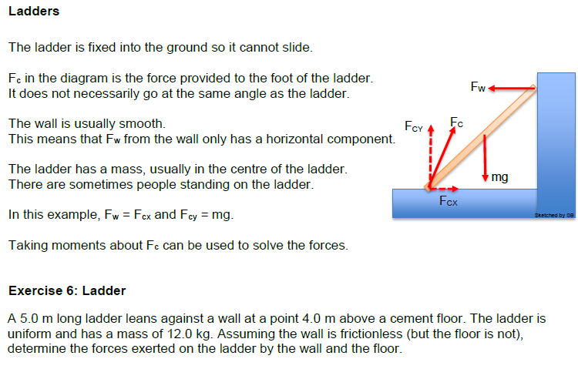

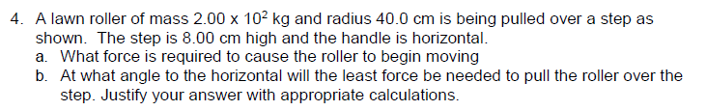

*Hint – draw diagram.

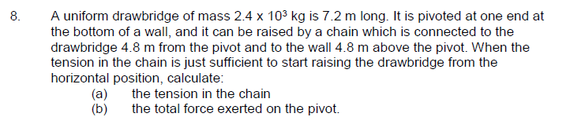

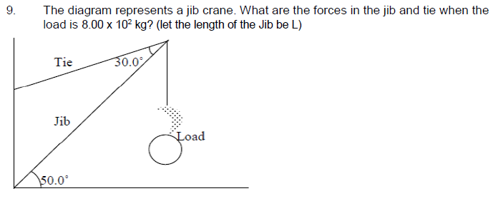

Answers:





